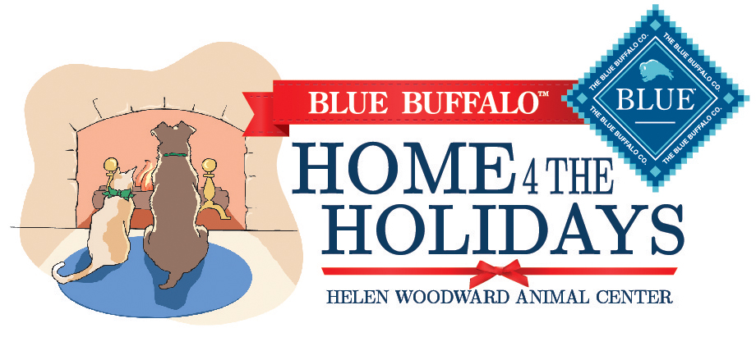

Making a Difference in the Lives of One Million Pets, Together

As makers of one of the finest natural pet foods, at Blue Buffalo® we know that a loving home is as important as wholesome nutrition to help dogs and cats live long, happy lives. **That’s why we’re proud to continue our partnership with the Helen Woodward Animal Center and our support of the Home 4 the Holidays pet adoption drive campaign.**

Free Adoption Kits

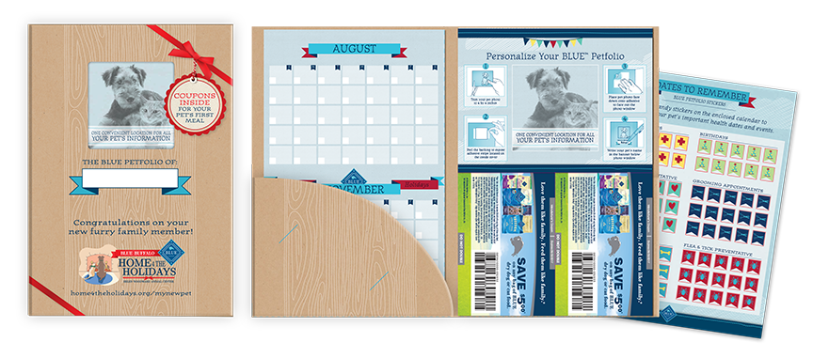

At Blue Buffalo, we’re committed to helping pets get their second chance at a loving forever home, which is why **we’re providing free adoption kits* and materials to help get these pets off to a healthy new start.**

**In each adoption kit your adopters will find:**

* Two $5 coupons to save on BLUE food
* A Petfolio to track a newly adopted pet’s important information and key dates
* Nutritional information for adopters to take home with their new furry family member

*\*Available to all participating shelters in the U.S., Canada and Puerto Rico, while supplies last.*

To learn more about BLUE and to find a retailer near you please visit [BlueBuffalo.com](http://www.bluebuffalo.com).

Love them like family. Feed them like family.®